**Computer Assignment 3B**

**Submitted by**

**Name: Rajiv Lochan Baruah**

**Roll No: 154103093**

|  |  |
| --- | --- |
| **Tabulation of discretised algebraic equation** | |
| Discretised Equation for Solving Stream Function | Ψi,j+1 + Ψi,j-1 + β2Ψi+1,j + β2Ψi-1,j + (∆x)2ωi,j = 2(1+ β2)Ψi,j |
| Discretised Equation for U-V Update | U =(Ψi+1,j - Ψi-1,j )/ (2∆y)  V = - (Ψi,j-1 - Ψi,j+1)/ (2∆x) |
| Discretised Equation for Vorticity BCs update | ωi,0 =ω i,1  ωi,M-1 = ωi,M-2  ωN-1,j = -(2/∆y2) (ΨN-2,j – ΨN-1,j)  ω0,j = -(2/∆y2) (Ψ1,j – Ψ0,j ) |
| Discretised Equation for Solving for Vorticity | 2(1+ β2) ωi,j = ) |
| Discretised Equation for Solving for Temperature | 2(1+ β2) Ti,j = |

|  |
| --- |
| Problem Definition |
| Screenshot (107).png |
| Discretised Domain |
| Screenshot (141).png |

**TABULATION OF RESULTS**

|  |
| --- |
| Streamlines |
| Screenshot (78).png |
| Temperature Contour |
| Screenshot (142).png |

|  |  |
| --- | --- |
| **Screenshot (115).pngU velocity along Y axis at x=2 and 2.5** | Screenshot (143).png  **Convergence History** |

**Discussion:**

The code developed for this problem was tested for various Aspect Ratio (L: H) and it was found that number of convection cells formed is strong function of the aspect ratio.

Keeping **L** (=5 units) constant

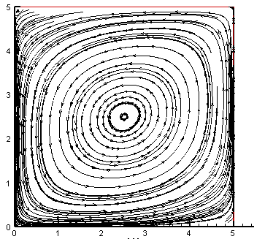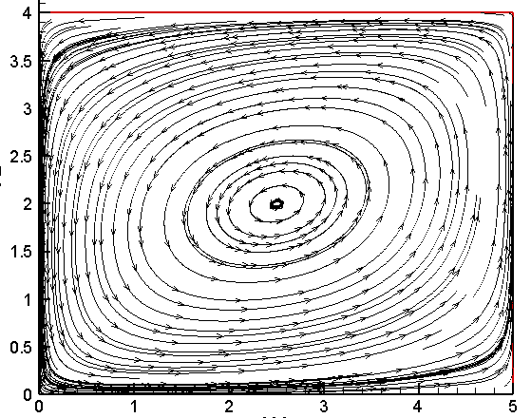

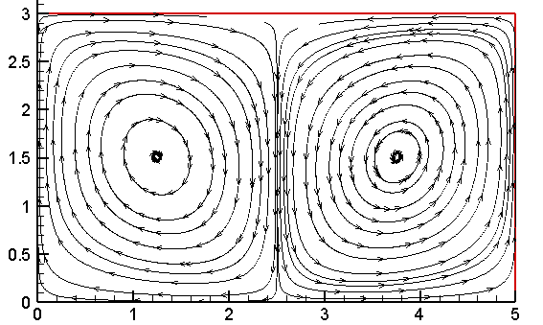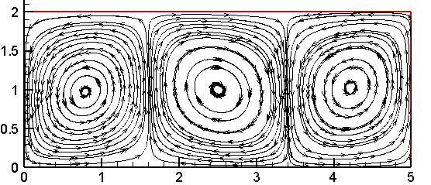

H=2 H=3 H=4 H=5

As we can see, the number of convection cells deceases as the aspect ratio approaches unity.

Keeping **H** (=1 units) constant

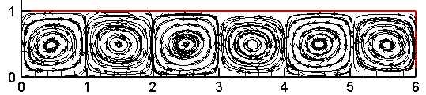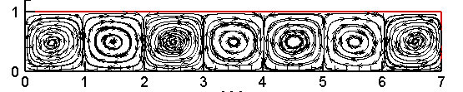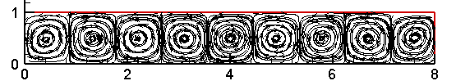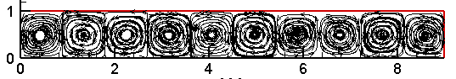

**L=9**

**L=8**

**L=7**

**L=6**

As we can see the number of convection cells increases as the L increases. Also the increase is proportional until L=8, after which the length scale of the convection cells changes and we get 10 convection cell for L=9.